

STRENGTHSCOPETM

FEEDBACK REPORT

Michele Farmer



CONFIDENTIAL

17 October 2018



**1. Introduction**

©Strengths Partnership Limited 2018 All Rights Reserved Michele Farmer Page 2 of 13

StrengthscopeTM is a revolutionary assessment tool that provides a comprehensive measurement of an individual’s strengths and the extent to which these are productively applied at work.

It is designed to help those completing it to identify their distinctive strengths. We define “strengths” as ways of thinking, feeling and expressing your emotions that lead to exceptional performance and energise or strengthen you.

Some of the benefits of understanding and applying your strengths at work include:

* Improved results and sense of achievement
* Higher levels of motivation and enjoyment at work as you will be applying your strengths more often
* Increased confidence and resilience to overcome performance blockages
* Improved understanding of your weaker areas and overplayed strengths

• Better teamwork

StrengthscopeTM is designed to be the first step in helping you genuinely ‘unleash your strengths’ and use them productively across as many situations as possible. In the sections that follow, you will be presented with information about your distinctive strengths, or ‘significant seven’, and how you can maximise these at work.

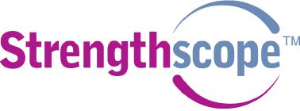

**2. Your ‘Significant 7’ strengths**

According to your responses to the questionnaire, we have identified the following core strengths for you:

**Compassion**



©Strengths Partnership Limited 2018 All Rights Reserved Michele Farmer Page 3 of 13

You demonstrate a deep and genuine concern for the well-being and welfare of others

**Critical thinking**

You approach problems and arguments by breaking them down systematically and evaluating them objectively

**Efficiency**

You take a well-ordered and methodical approach to tasks to achieve planned outcomes

**Empathy**

You readily identify with other people’s situations and can see things clearly from their perspective

**Initiative**

You take independent action to make things happen and achieve goals

**Relationship building**

You take steps to build networks of contacts and act as a ‘hub’ between people that you know

**Strategic mindedness**

You focus on the future and take a strategic perspective on issues and challenges



**3. Your strengths profile**

©Strengths Partnership Limited 2018 All Rights Reserved Michele Farmer Page 4 of 13

The graph below shows all your strengths on a 1-10 scale compared to the comparison group. The length of each bar on the graph indicates the extent to which this aspect of work energises you and should not be confused with level of skill or competence.

Your Significant 7 strengths appear at the centre of the graph.

The graph also shows how your strengths can be grouped into four clusters: Emotional, Relational, Thinking and Execution. The definition for each cluster is given in the text adjacent to it.

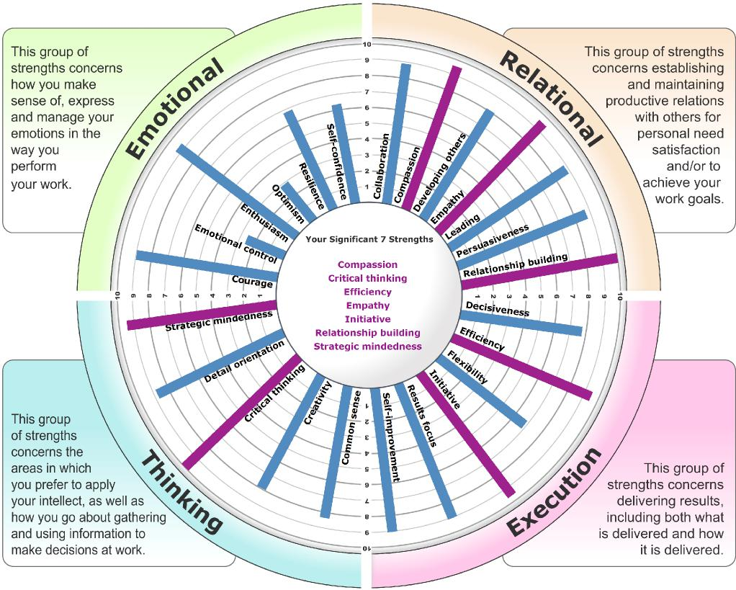

On the following pages, we have presented more detail on each of your strengths, including a more detailed description of each of your strengths together with the likely consequences if you overuse or overdo the strength, i.e. if it goes into ’overdrive’.



Your ‘Significant 7’ strengths are described below in alphabetical order. Please note that not all statements will apply to you equally but should provide you with some indicators as to how your strengths appear at work.

©Strengths Partnership Limited 2018 All Rights Reserved Michele Farmer Page 5 of 13

At the foot of each section, each strength is described when it is in ‘overdrive’, i.e. when it is being over-used or used in an inappropriate situation.

These statements should help you establish the extent to which you are currently using your strengths optimally.

**Compassion**

***You demonstrate a deep and genuine concern for the well-being and welfare of others***

* You are concerned with the general well-being and welfare of others
* You show kindness to others in times of need or crisis
* You notice or follow up when a co-worker is not performing at her/his usual standard
* You put others' needs ahead of your own

**Strength in overdrive:** you may allow people to take advantage of you and your concern for them; you may become an 'agony aunt' who people come to depend on

**Critical thinking**

***You approach problems and arguments by breaking them down systematically and evaluating them objectively***

* You enjoy dissecting arguments in order to understand their logic
* You find it easy to simplify difficult problems or situations
* You seek out additional facts and data to understand and resolve problems
* You separate a problem into its component parts in order to see meanings, relations, and assumptions that might otherwise remain buried

**Strength in overdrive:** you continuously question or look for flaws in proposed solutions and arguments. This may be perceived as negative and over-critical by others

**Efficiency**

***You take a well-ordered and methodical approach to tasks to achieve planned outcomes***

* You have efficient, well-ordered systems for working
* You enjoy taking on the planning of large events such as a conference or large party
* You are good at coordinating a complex array of tasks and people in order to achieve the best possible outcome
* You enjoy making action plans and lists detailing what needs to be done, by when and by whom
* You are eager to engage others (e.g., your manager and partner) in establishing priorities and agreeing plans

**Strength in overdrive:** your excessive emphasis on organisation and efficiency may leave little scope to incorporate new information and options in your planning and execution as the task or project unfolds



**Empathy**

©Strengths Partnership Limited 2018 All Rights Reserved Michele Farmer Page 6 of 13

***You readily identify with other people’s situations and can see things clearly from their perspective***

* You find it relatively easy to 'put yourself in another's shoes'
* You appreciate not only what people are saying, but also why they are saying it
* You have a keen interest and understanding of 'what makes people tick'

**Strength in overdrive:** you can become so immersed in others' situations that you may start identifying with them as your own and lose the ability to provide objective support and guidance

**Initiative**

***You take independent action to make things happen and achieve goals***

* You are ready to initiate action without being asked
* You regularly solve problems or take action before being required or asked to do so
* You independently anticipate and deal with any problems or roadblocks to task completion
* You involve yourself early in the process to ensure that your input is included

**Strength in overdrive:** you start new initiatives and activities habitually, without always considering their chances of success or their political consequences

**Relationship building**

***You take steps to build networks of contacts and act as a ‘hub’ between people that you know***

* You actively build close relationships with co-workers and acquaintances
* You have a wide network of colleagues and contacts
* You enjoy meeting new people and getting to know them
* You are the sort of person who 'knows everybody' and through whom information flows

**Strength in overdrive:** your focus on initiating new relationships and contacts may become an end in itself and may take up a disproportionate amount of your energies

**Strategic mindedness**

***You focus on the future and take a strategic perspective on issues and challenges***

* You discover imaginative strategies that can rewrite the rules of the existing operating environment
* You demonstrate the ability to step above immediate concerns and to see the 'big picture'
* You are oriented towards the future and how the team, organisation and market landscape might look
* You enjoy predicting trends and scenarios of possible alternative futures

**Strength in overdrive:** you can be so focused on the 'big picture', including future scenarios and opportunities, that you may skim over current realities



**4. Visibility of strengths**

©Strengths Partnership Limited 2018 All Rights Reserved Michele Farmer Page 7 of 13

This section indicates the extent to which you and your nominated co-workers/raters believe your strengths are visible in the way you behave and perform at work. Your self-rating is indicated by the purple arrow, while the purple line indicates the average rating of all co-workers/raters who responded to the questionnaire. The frequency with which your co-workers/raters selected each option is shown by the blue bars on the chart.

The right hand chart indicates the extent to which you should use each strength in order to optimise your contribution and impact. Your response, your co-workers’ responses and the raters’ average are shown in the same way.

The graphs below are based on feedback from 8 rater/s.

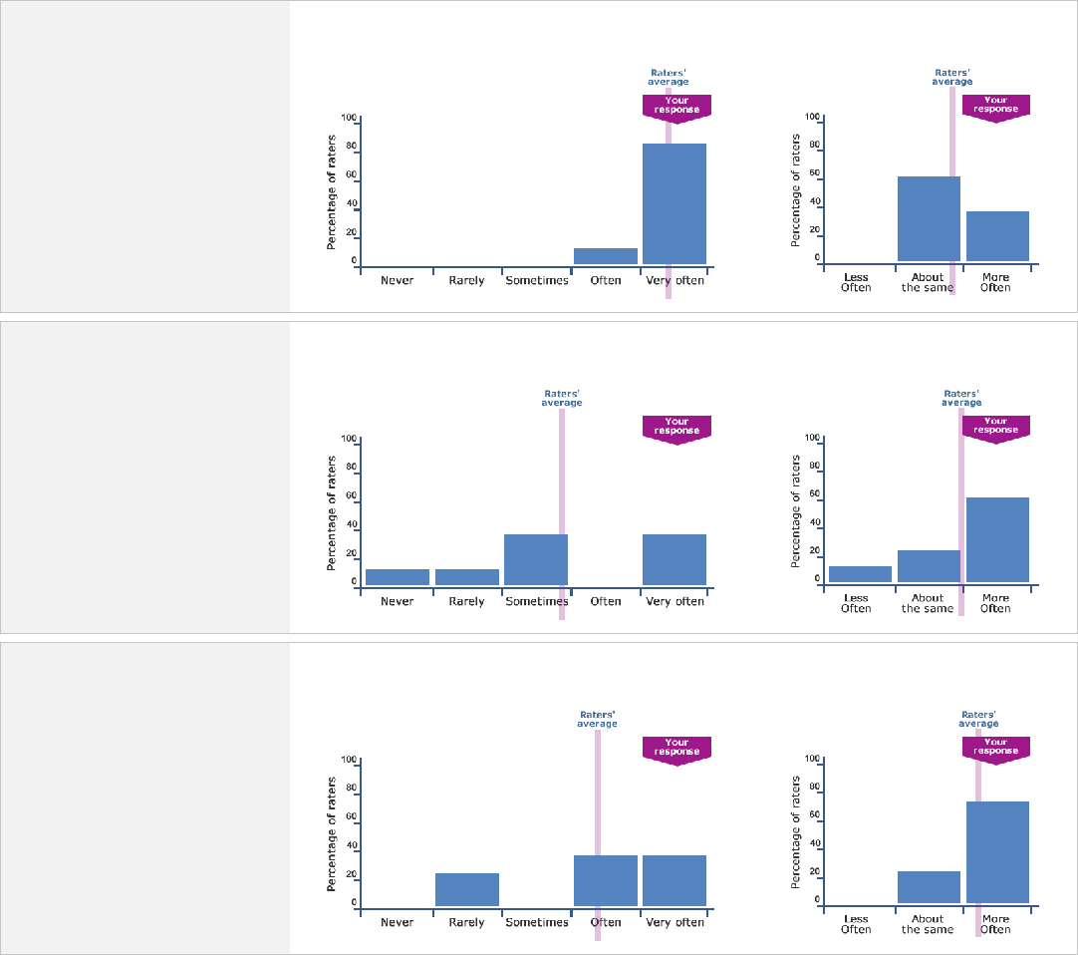

**Efficiency**

How often raters see this strength: How often raters would like to see this

strength:

**Compassion**

How often raters see this strength: How often raters would like to see this

strength:

**Critical thinking**

How often raters see this strength: How often raters would like to see this

strength:



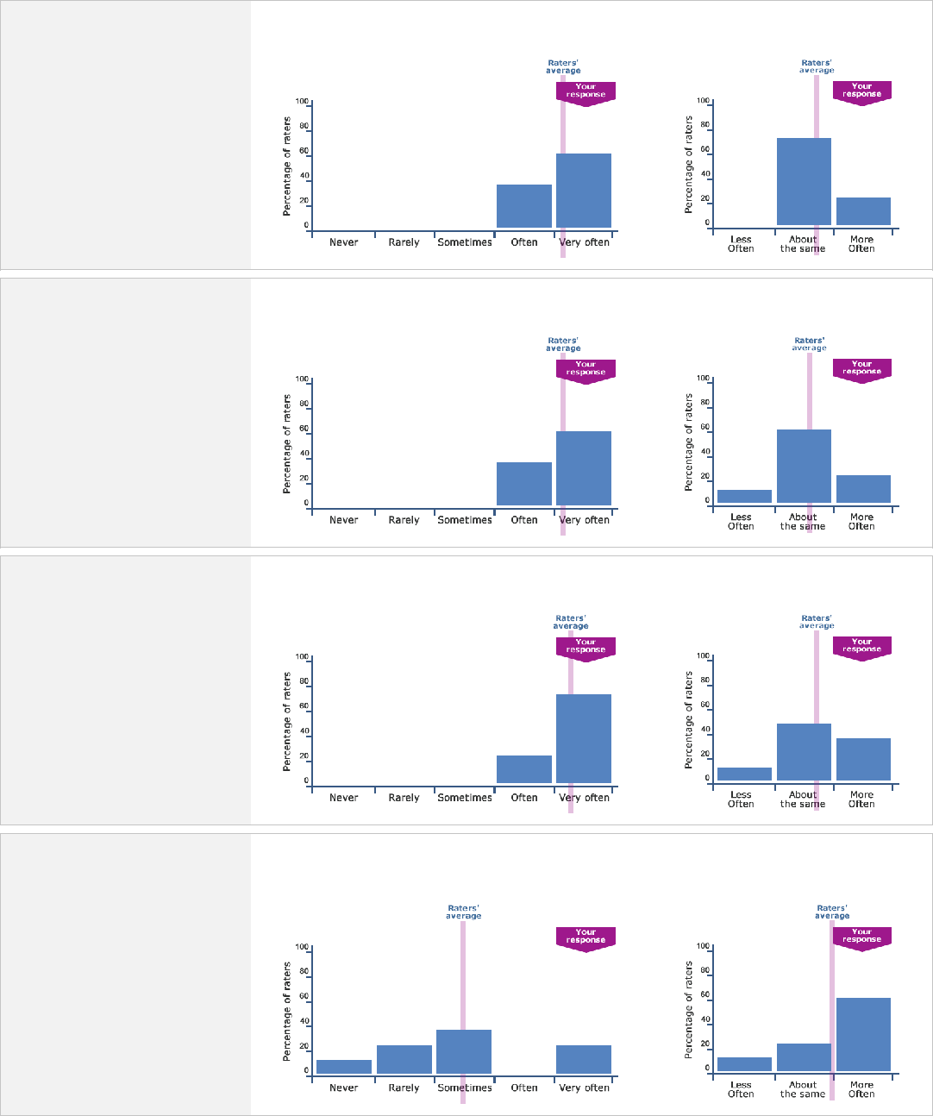

**Strategic mindedness**

How often raters see this strength: How often raters would like to see this

strength:

**Relationship building**

How often raters see this strength: How often raters would like to see this

strength:

**Empathy**

How often raters see this strength: How often raters would like to see this

strength:

How often raters see this strength: How often raters would like to see this

strength:

**Initiative**

©Strengths Partnership Limited 2018 All Rights Reserved Michele Farmer Page 8 of 13



**Verbatim Quotes from raters**

©Strengths Partnership Limited 2018 All Rights Reserved Michele Farmer Page 9 of 13

**What my raters value most:**

***“****Michele's strengths and contributions are countless. Her ability to show compassion when faced with others problems would break most people. She is a credit to UCL.****”***

***“****This person is extremely empathetic and her people skills is exemplary. it is difficult in her current role for her to implement procedures and be creative - this does not mean that she does not have the skills to do so but is reflective of the current job structure.*

*This person has indicated to me on numerous occasions her willingness to deal with complex situations and has never complained about the urgency required - this ability to 'cope' is one of her major strengths. Her spirit of collegiality is indeed one of her greater contributions to colleagues and ultimately to the organization.****”***

***“****Michele is dependable, flexible, friendly, hard working person I know. She is very creative, trustworthy, honest, enthusiastic and very dedicated in whatever she has her mind set on, inside and outside of work. She is able to turnaround a negative problem into a positive solution working environment. She will always do her best, meet deadlines and take on new challenges all with a positive attitude. Michele is a great person to work with and very privileged to have done so.****”***

***“****This person shows unlimited understanding and patience when dealing with those who have invisible problems, e.g. mental illness, compulsive conditions, phobias, etc. Nothing is odd or peculiar to her. She is also meticulously honest about her own problems. She goes to great lengths, above and beyond her job description, to make people feel comfortable and to give them the support that they need.****”***

***“****Willingness to help / contribute****” “****Her proactivity.****”***

***“****Their vivacity and commitment to an important and necessary cause; their emphasis on the human side of things and how everything should be framed around those; their resilience and initiative in an institution that can seem to place little value (despite the legal requirements and the genuine impact it has on people's lives) on Michele's crucial area. Her contribution makes a vast, if unrecognised, difference to a large number of people's lives across the institution.****”***

***“****how helpful she is when dealing with colleagues and students. She also listens well and helps solve any problems. She is very sympathetic and generous.****”***



**What my raters recommend would help optimise my strengths and contribution:**

©Strengths Partnership Limited 2018 All Rights Reserved Michele Farmer Page 10 of 13

***“****It would be prudent to step back from some situation's and adopt a less emotional approach. this would give her the ability to take the upper hand in a meeting and get the results she wants.****”***

***“****Strategic 'thinking' time is essential for planning purposes - this is not always possible with the demands of most roles, however, the individual should attempt to create this.****”***

***“****Michele strengths is Communication. She is a good listener, support people when they are feeling down and vulnerable and respects everyone in meetings, emails or writing documents. She has rasied money for charities and other orgainsations inside and outside of work. I believe Michele is a great candidate and support her in what she wants to acheive in life.****”***

***“****Focussing more on efficiency to get more done regardless of schedules.****”***

***“****Michele knows herself where her weaker points are and works to over come them and to recruit those around her who are stronger in those areas to assist, mean that any weaker points disappear. Weaker points are relative - not as strong as other areas, rather than being actively weak - and are often the fli p side of her strengths. Organisation and focus seem to some times be in need of development - her creativity and enthusiasm can benefit from being run through a more mechanistic mind, at times. Bizarre as it may sound, but her commitment may benefit from being reigned in from time to time, sacrificing the short term to preserve her strength for the long term - the 'put your oxygen mask on first' argument.****”***

***“****I can't think of any....****”***



**5. Making the most of your strengths**

©Strengths Partnership Limited 2018 All Rights Reserved Michele Farmer Page 11 of 13

©Strengths Partnership Limited 2018 All Rights Reserved Michele Farmer Page 12 of 13

In completing the questionnaire, you stated that within your current role, you have the following opportunities to use your Significant 7 strengths, from ‘never’ to ‘very often’, as shown by each dial.

Next to each dial, there are some questions to help you get the most from each of your Significant 7 strengths. These will help you think about how you can apply your strengths more productively, regardless of how often you are able to use them at present.

|  |  |
| --- | --- |
|  | 1. What steps can you take to help vulnerable, sensitive or new people in your team/organisation to feel emotionally supported and valued? 2. In what new ways can you develop social and emotional bonds among people within your team/organisation? What specific activities can you suggest or organise to build a stronger team spirit and supportive climate? 3. How can you ensure you use this strength in a way that builds self-sufficiency in others as opposed to dependency? |

|  |  |
| --- | --- |
|  | 1. What opportunities are there to get involved in tackling complex problems which are frustrating the performance of the team/organisation? 2. How can you ensure you clearly communicate the steps in your thinking (including underlying assumptions) to others to ensure they remain supportive of your arguments and conclusions? 3. How can you ensure that others see the full value of your problem-identification, criticism and counter-arguments as constructive as opposed to negative and overly critical? |

|  |  |
| --- | --- |
|  | 1. How can you apply your strength to identify and eliminate inefficient processes that create wastage or drain morale and energy? 2. What opportunities exist within or outside your work area that require strong co-ordination and organisational skills? How can you get more involved in these activities? 3. How can you ensure that others get the most from your efficiency strength and don’t see it as constraining or controlling? |



|  |  |
| --- | --- |
|  | 1. How can you use your empathy to build closer working relations with your stakeholders? What improvements would you expect to see in the relationship as a result? 2. In what ways could you use your empathy to help others understand difference and conflict from different perspectives to promote understanding and cohesion? 3. How can you use your empathy to overcome difficulties working with someone you don’t relate to well? |

|  |  |
| --- | --- |
|  | 1. What opportunities exist for you to take the lead on important projects or tasks where others appear reluctant or no clear responsibility has been assigned? 2. How can you bring other people along with you to ensure the actions and decisions you are proposing have the best chance of success? 3. How can you guard against initiating too many things? |

|  |  |
| --- | --- |
|  | 1. What relationships with key stakeholders outside the team can you strengthen which will help raise its visibility and achieve its goals? 2. How can you build a strong network outside the organisation? What opportunities are there to make use of this network to help achieve your work and development goals? 3. How can you strengthen your role as a ‘hub’ and connector of people who would benefit from knowing each other and working together? What are the benefits to you of taking on such a role? |

|  |  |
| --- | --- |
|  | 1. How can you get more involved in devising strategy for your organisation or work area? 2. How can you help others to think more strategically? 3. What can you do to ensure your strategic ideas and aspirations get sufficient ‘air time’ with the right decision-makers in the organisation? |



**StrengthscopeTM strengths in full**

©Strengths Partnership Limited 2018 All Rights Reserved Michele Farmer Page 13 of 13

The definitions below describe all 24 of the StrengthscopeTM strengths for your reference.

**Collaboration:** You work cooperatively with others to overcome conflict and built towards a common goal

**Common sense:** You make pragmatic judgments based on practical thinking and previous experience

**Compassion:** You demonstrate a deep and genuine concern for the well-being and welfare of others

**Courage:** You take on challenges and face risks by standing up for what you believe

**Creativity:** You come up with new ideas and original solutions to move things forward

**Critical thinking:** You approach problems and arguments by breaking them down systematically and evaluating

them objectively

**Decisiveness:** You make quick, confident, and clear decisions, even when faced with limited information

**Detail orientation:** You pay attention to detail in order to produce high quality output, no matter what the pressures

**Developing others:** You promote other people’s learning and development to help them achieve their goals and fulfil

their potential

**Efficiency:** You take a well-ordered and methodical approach to tasks to achieve planned outcomes

**Emotional control:** You are aware of your emotional ‘triggers’ and how to control these to ensure you remain calm

and productive

**Empathy:** You readily identify with other people’s situations and can see things clearly from their

perspective

**Enthusiasm:** You demonstrate passion and energy when communicating goals, beliefs, interests or ideas you

feel strongly about

**Flexibility:** You remain adaptable and flexible in the face of unfamiliar or changing situations

**Initiative:** You take independent action to make things happen and achieve goals

**Leading:** You take responsibility for influencing and motivating others to contribute to the goals and

success of their team and organisation

**Optimism:** You remain positive and upbeat about the future and your ability to influence it to your advantage

**Persuasiveness:** You are able to win agreement and support for a position or desired outcome

**Relationship building:** You take steps to build networks of contacts and act as a ‘hub’ between people that you know

**Resilience:** You deal effectively with setbacks and enjoy overcoming difficult challenges

**Results focus:** You maintain a strong sense of focus on results, driving tasks and projects to completion

**Self-confidence:** You have a strong belief in yourself and your abilities to accomplish tasks and goals

**Self-improvement:** You draw on a wide range of people and resources in the pursuit of self-development and learning

**Strategic mindedness:** You focus on the future and take a strategic perspective on issues and challenges

**If you have any questions about the content of this report, please contact the Strengths Partnership at** [**support@strengthscope.com**](mailto:support@strengthscope.com)

Please note that the content of this report remains proprietary to Strengths Partnership Ltd, and that any distribution or copying of the report or any of its content is prohibited unless prior agreement is made with the company, evidenced in writing.