Women at UCL: Presence and Absence - The Main Exhibition
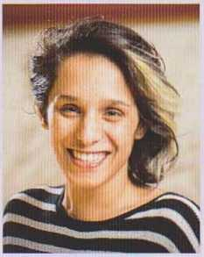
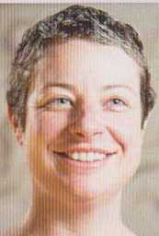
Asma Ashraf, Research Nurse, Institute for Women's Health
"Asma is the person who most helped me see that I could usefully support the work of female activists through my position and experience at the UCL Institute for Women's Health, even though I certainly do not consider myself an activist - I am but an academic!"
Fiona Addison,
Volunteering Development Coordinator, UCLU
"I've managed Fiona for almost 8 years and, throughout that time, have been inspired by her dedication, creativity and personable approach to work and to life. I know that many, many students have had their time at UCL transformed by her support."

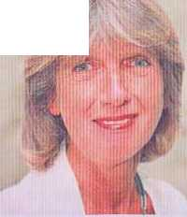
Jan Atkinson, Emeritus Professor, Division of Psychology and Language Sciences
"Jan Atkinson is an impressive woman in science who worked her way up to a professorship at a time when women were severely underrepresented in psychology. Such a true scientist is an inspiration to all of us and shows us that research is not just a job but a calling."
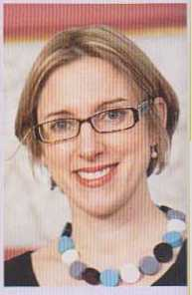
Sarah-Jayne Blakemore, Professor, Division of Psychology and Language Science
"Sarah's lab was a revelation. She ran an innovative, inspiring research programme. At the same time she had a clear priority for family Sarah's example drastically changed my perspective. Where once I saw academic 'role models' bragging about inhumane hours, I now saw the opportunities that come with flexibility."'
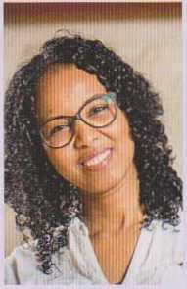
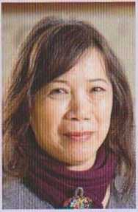

Lai Fong Chiu, Principal Research Associate, UCL Energy Institute
"Lai Fong has been a great mentor who, despite not formally supervising me, has always had an open ear and some encouraging words. Her enthusiastic and always curious nature has been a continuous inspiration to keep questioning the seemingly obvious and look deeper into the relation between the built environment and its occupants."
Muna Elmi, Research Associate, Computer Science
"Through Muna's hard work she has succeeded in her field and has given me confidence that I can achieve more than I have dreamt about (and I dream pretty BIG- Nobel prize BIG). I asked Muna to become my mentor and without hesitation she agreed. As a Somali student she stands as one of the very few Somali women I am able to see as a mirror to my future as a great scientist."

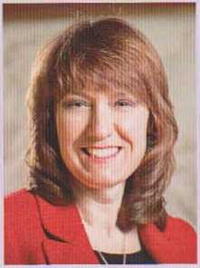
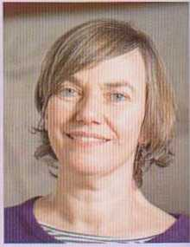
Michele Farmer, Disability IT Support Analyst, Student Disability Services
"Michele is a credit to her field. She is the sole point of contact for all staff and students across UCL who use or need assistive technology. I doubt that there is any part of UCL remaining untouched by her support and assistance."
Louise Fryer, Teaching Fellow, SELCS
"Since I met Louise I have always been inspired by her ability to combine her role as an academic and as a professional audio describer for the blind and partially sighted. I always admired the passion with which she approached her work, as well as her dedication to her field of expertise."

