**Excerpt from an email to the project coordinator about chairs.**

‘Following the visit to the furniture company I have the following observations.

I attach pictures to demonstrate the various points.

The concerns I have about the mesh chair are as follows:

* It is not possible to adjust the lumbar curve – this means that some people will find too curved or not enough, which may be uncomfortable for them.
* Some of the mesh designs do not allow for the back height to be adjusted which will also mean the lumbar curve will be at the wrong height for some.
* There is no pelvic tilt facility – (this facility is excellent for helping the user to sit on their ‘sitting bones’ thus keeping their spine in correct alignment).

Picture 1 below where the lady is sitting upright there is a large percent of her back that is not in contact with the back of the chair and so is not fully supported.

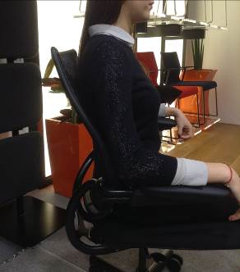

Picture 2 below shows the lady trying to fit her back into the fixed curve of the seat and although the contact is full – the spine and neck are not at a good angle and this will cause discomfort.

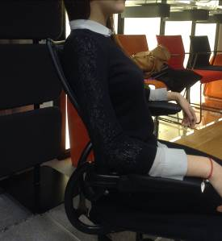

Picture 3 below shows the padded chair. This has the following adjustments available.

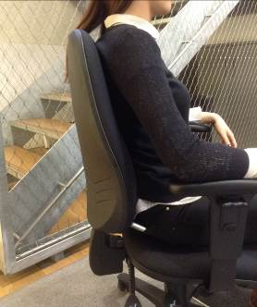

* Pelvic tilt
* Seat slide
* Ratchet for raising the back up and down
* Back tilt that can be adjusted.
* Padded back to be gentler on sore spots if people have some kind of injury.

The image shows the lady sitting normally on there, you can see she has almost 100% contact which means that the weight of her brain and skull will be supported by the back of the chair and not compressing the spine in the course of the day.

I hope this makes sense but please contact me if you need any further information.

The issue we have though is that whatever chair we go for it will not please everyone but I think the chair with the more adjustments would give us more flexibility.

Regards

Michele’